(Approx. 685 words)

Exploring Linux, A Backup Solution for Linux Systems
By Alan German, Treasurer
Ottawa PC Users' Group, Ontario, Canada
https://opcug.ca
Editor: brigittelord (at) opcug.ca

While several disk imaging programs are available to back up Linux systems, very few feature a graphical user interface (GUI). Foxclone is one of the exceptions. Furthermore, it is open-source software with two major features that make it worthy of further examination.

Foxclone can be downloaded in two versions, each providing an ISO file. One version, labeled as standard, is based on Ubuntu Linux Version 18.04 (Bionic Beaver). The focal version is based on Ubuntu Linux Version 20.04 (Focal Fossa).

I selected the most recent version and installed the ISO file on a multi-boot USB drive using Yumi (https://pendrivelinux.com/yumi-multiboot-usb-creator/). Foxclone isn't supported directly in Yumi, so it is necessary to select Try an Unlisted ISO as the source for the ISO file. Once the relevant files have been copied, the USB can be booted, and Foxclone is listed in the boot menu under the category Unlisted ISOs as the file foxclone51_focal.iso.

Booting from this menu item loads a Linux desktop that includes icons for Foxclone and the Fox guide user manual: a file manager and a web browser. The Linux panel (equivalent to the Windows taskbar) is displayed across the bottom of the screen, with a button to access the main menu in the lower-left corner. The options available are more limited than those for a full Linux distro. However, they still include applications such as a text editor, PDF reader, Terminal, and the GParted partition editor.

Running Foxclone displays the main program window with sections where the drive is to be backed up, its partitions, and the destination drive and partition, which can be selected for the backup process. The program scans the computer's filesystem and populates the entries for the source and target drives. Consequently, the backup drive must be present when Foxclone is initiated so that it can be displayed as being available as a target.

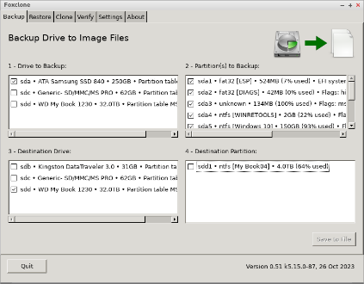
Once a drive to be backed up has been selected, all the partitions on this source drive are automatically selected for backup. Still, individual checkboxes allow the selection to be refined. Selecting an external USB drive as the destination drive and pressing Save to File brings up a second dialogue box where the target location can be further specified by browsing the drive's file system. Other options are to create a backup folder and overwrite the current date (in the format 20240215) as the default prefix for the names of the backup files.

A final dialogue box requests confirmation of the backup selections, and pressing OK starts the backup process. The result is essentially a series of compressed image and text (log) files that relate to the contents of the individual disk partitions (identified here as sda1, sda2, etc.)

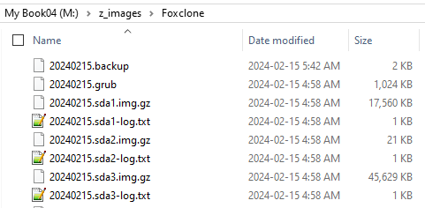

Restoring a disk image or partition is essentially the reverse of the backup process and is accessed through the Restore tab at the top of the program window. Other tabs provide options to clone disks, verify backups, and change various program settings. An About tab indicates the software version and its release date, together with a notice that the program is free software under GNU General Public Licence (GPL) terms.

The Foxclone User Guide (63 pages) can also be downloaded from the developer's website. The manual provides clear, detailed instructions about every aspect of using the program, with the text illustrated using annotated screenshots. Documentation is even provided on the utility programs (image viewer, text editor, etc.) provided in the distribution, with overviews of disk partitioning and bootloaders.

Foxclone supports both Linux and Windows, runs from a bootable USB drive, is intuitive, and has excellent documentation. The program runs a Linux distro as a live USB, and while this won't be an issue for Linux users, even those familiar only with Windows will know to double-click the Foxclone icon on the desktop to run the program. The user interface is simple, and the backup process is easily understandable, so running this software is worth a try.

Bottom Line
Foxclone (Open source)
Andy Hardwick
https://foxclone.org

